Visualizing and Predicting Heart Diseases with an Interactive Dash Board

Team ID: PNT2022TMID10044

Faculty Mentor: Team Leader : Sakthivel M

T.K.P Rajagopal Team Member : Sadhana M

Team Member : Sirisha G

Team Member : Sneha Bharathi V

Technical Architecture

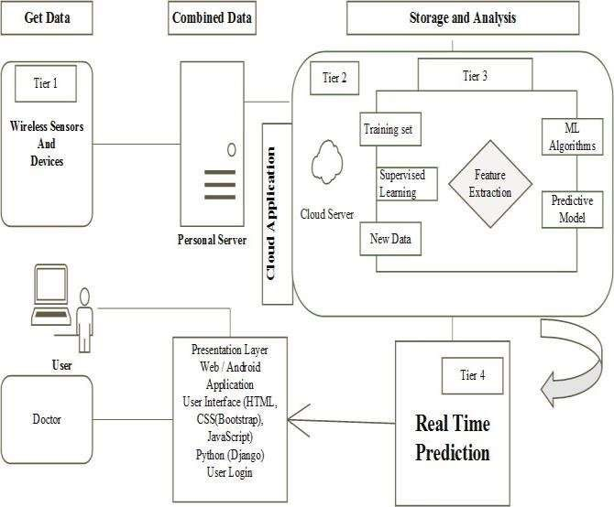

Table-1 : Components & Technologies:

|  |  |  |  |
| --- | --- | --- | --- |
| S.No | Component | Description | Technology |
| 1. | User Interface | How user interacts with application e.g. Web UI, Mobile App, etc. | HTML, CSS, Python etc. |
| 2. | Application Logic-1 | Logic for a process in the application | Python |
| 3. | Application Logic-2 | Logic for a process in the application | IBM Cognos Analytics |
| 4. | Application Logic-3 | Logic for a process in the application | IBM Watson Assistant |
| 5. | Database | Data Type, Configurations etc. | MySQL, etc. |
| 6. | Cloud Database | Database Service on Cloud | IBM DB2, IBM Pak etc. |
| 7. | File Storage | File storage requirements | Use Professional Records Storage, IBM Block Storage or Other Storage Services. |
| 8. | External API | Purpose of External API used in the application | IBM SPSS, etc. |
| 9. | Infrastructure (Server / Cloud) | Application Deployment on Local System /  Cloud  Local Server Configuration:  Cloud Server Configuration : | Personal Server, IBM Cloud Server etc. |

Table-2: Application Characteristics:

|  |  |  |  |
| --- | --- | --- | --- |
| S.No | Characteristics | Description | Technology |
| 1. | Open-Source Frameworks | Open-source frameworks used | Technology of Opensource framework – Django or Flask in Python. |
| 2. | Security Implementations | Security / access controls implemented, use of firewalls etc. | e.g. Privacy - Encryptions, IBM Security Manager etc. |
| 3. | Scalable Architecture | Scalability of architecture (3 – tier, Microservices) | Technology used - IaaS, PaaS, SaaS (IBM Cloud). |
| 4. | Availability | Availability of application | Technology used - The Availability of getting used to this software or  product  design is through by accessing IBM  cognos Analytics and IBM cloud. |
| 5. | Performance | Performance of the application | Technology used - The performance  should be fast relaying. This prediction  system should be made available in cloud to ensure better  accessibility and setting a milestone in providing good quality affordable healthcare. |

References :

https://www.ibm.com/products/cognos-analytics https://cloud.ibm.com/catalog/services/watson-assistant https://www.ibm.com/in-en/cloud-paks https://www.ibm.com/cloud